Chris Piech, Mehran Sahami and Julie Zelenski Section #5

Code in Place May 13, 2021

Preparing for Section 5

This section covers Lists and Files, but above all it is a chance for you to wrap up your time together as a group. We have purposely designed a light section so that you can get through the material and should have time to end well.

## **Learning Objectives**

**This is your last section!** As such your main mission is to “tie a bow” on the experience you have had with your sectionees. Leaving on a good note is important for you and the students.

This week the course is covering content that may be of use to your students in their final project. We are covering Lists, Strings and Files. In your section we want students to get practice with **Lists, and Files.**

## **What can I assume students already know?**

You should assume that students are only slightly familiar with lists, since they were discussed last week but not used in the assignment, and have not seen anything about files before, since they are in Wednesday’s lesson.

**Recommended Section Plan**

This week you get to choose the path you take. You are in charge of your section so you can teach it how you would like. If you don’t have time, we would recommend fun + relaxed!

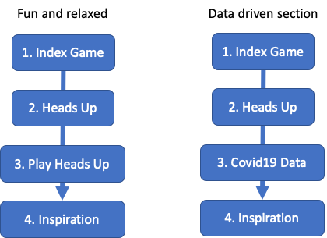

### 

### ***Social Time [5 minutes]***

While students are joining the meeting, take a few moments to catch up and see how everyone is doing. Can you start by telling everyone a story from this history of CS or from your own life?

### ***Play Index Game to Review [7-10 minutes]***

Slowly go over the code in stages 1 through 4 (see the stages in the code comments).

Run the program (several times) to play the game. First, let all students answer. Then ask students who have gotten a question correct to let others go first.

**Pro tip:***Keep the diagram of the list, with the indices visible on your screen. Put it in the comments of the code if necessary.*

After you are done, once again go over the four parts of the code and see if there are questions.

***Program Heads Up! [15 minutes]***

* Quickly run the solution so they get what they are supposed to do.
* (given time) Perhaps jokingly pretend that you are going to hard code a list with all of the words (inside your headsup.py file). Talk about why we separate code + data.
* Read the lines from a file into a list and finish the game.

***Play Heads Up! [5 minutes]***

As section leader you need to coordinate. Keep an ordered list of the attendees and have them be the “guesser” one at a time.

**Pro tip:** Note that this game serves as a review of the concepts that we have covered in class. Do feel free to add to the set of words if you think I have missed anything!

***Say goodbye [5 minutes]***

Take a moment to talk “big picture” with your students. Why is it an interesting time to be learning computer science? Say thank you to the students. It might seem strange to thank them, but remember that they have put in 40ish hours or more into learning.

Keep things concrete! If you think Data Science is interesting, point them to the extra problem on today’s section and say that is their next step in learning.

While this is your last week, the students have one more week for final projects. After that we are going to (1) collect and celebrate their work (2) keep the community open for folks who are finishing late, or just want to keep hanging out. We will provide a set of next steps for them on Friday next week.

**Data Science COVID-19 problem, at your own risk.**

50 minutes is tight! We don’t expect you to get to the Data Science problem, but rather to use it as an exemplar of what they can do. Do provide solutions. You might want to blaze through the problems and get to the COVID-19 problem during your section. Awesome. But if you do, make sure you really practice and prep all parts so that it is smooth. Your transitions would have to be very clean to get this problem in without rushing. Be careful not to miss the chance to say goodbye!

And on that note, thank you. Truly. This has been a wonderful ride and we can’t believe we are on the last week.